**Hidden Marov Model**

A story where a Hidden Markov Model(HMM) is used to nab a thief even when there were no real witnesses at the scene of crime; the heroic application of HMM to shrewdly link two apparently unrelated sequence of events in this pursuit of truth.

**A story where a Hidden Markov Model(HMM) is used to nab a thief even when there were no real witnesses at the scene of crime; you’ll be surprised to see the heroic application of HMM to shrewdly link two apparently unrelated sequence of events in this *pursuit of truth*.**

**The plot**

George is the manager of the baggage delivery department at [Barra Airport (Scotland)](https://en.wikipedia.org/wiki/Barra_Airport_(Scotland)) Airport   
   
Managing this small and scarcely visited airport would have been easily if it was not for the constant fights between Bob and William, the baggage handlers.  
Bob and William always fight over the workload, which could be one of a suitcase, backpack or a bag.   
To settle these brawls one and for all, George set up a work roster. “This work rooster will set clear expectations on the division of labour in handling the baggage” , he thought.

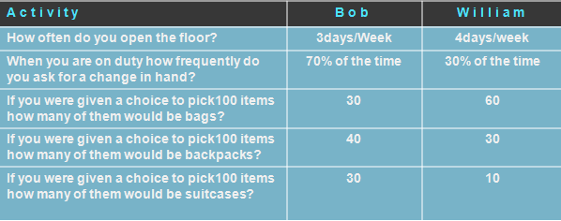

But he was wrong, just when he wanted to sit back and relax, a complaint comes and falls in his lap.   
*A diamond studded necklace is missing from the suitcase of a celebrity who landed.*   
George knows that this is work of either of Bob or William, but then how could he catch the real culprit?

‘This is complicated’ he thought, as both of them wouldn't confess and to make matters worse the CCTV recording was set up only in the baggage claim area and not in the baggage handling area. This means there can be no conclusive evidence of who picked the suitcase and put it on the belt.

***How can George nail the culprit with no conclusive evidence of who loaded the tampered suitcase?***

**Ingenious George applies HMM**

Impaired by the lack of conclusive evidence, George turns to science to explore the possibility of finding a statistical cue that could point the needle to the prime suspect.

He reads about Hidden Markov Models (HMM).

He learns that

“*One of the applications of HMM, is to predict the sequence of state changes, based on the sequence of observations.”*

He learns that HMM can be used to model a system that   
1. Has finite internal states that generate a set of external events (observations)   
2. The internal state changes are invisible (hidden) to a viewer outside the system  
3. The current state is always dependent on the immediate previous state only (Markov process)

Voila! George quickly correlated his situation with a HMM model. George figures that if the CCTV footage from the baggage claim area can be considered as the observation sequence, he could populate the model and use it to expose the ‘hidden’ sequence in which Bob and William would have operated.

Further, William takes over from Bob when Bob calls for a change of hand and vice versa. By relying on just the last call for change, Bob and William apparently were following the Markov Process!

George is now excited at the prospect of solving the case. He creates a mapping of the HMM to the actual scenario which looks something like this…

Having related the building blocks of HMM to his challenge, he first needs to find a way to populate the HMM.

To fully populate the model, he needs

1. Start probabilities – What are the chances of starting in a state? Or in other words – who was more likely to have opened the floor?

2. Emission probabilities – What are the chances of an observation occurring in a state? What are the chances of say ‘a bag being loaded by Bob’?

3. State Transition probabilities – How frequently do the states change? What are the chances of say William asking for Bob to take over?

While HMM is crucial to solve the case, its role is just to model the situation. To solve the case however, he would need to use the HMM that he would create with the ‘Viterbi Algorithm’.

Using Viterbi algorithm George would be able to uncover the most probable sequence of state changes that caused the observations.

So, once he has populated the model, he planned to use the Viterbi algorithm to get the hidden sequence in which Bob and William operated from the observation sequence.

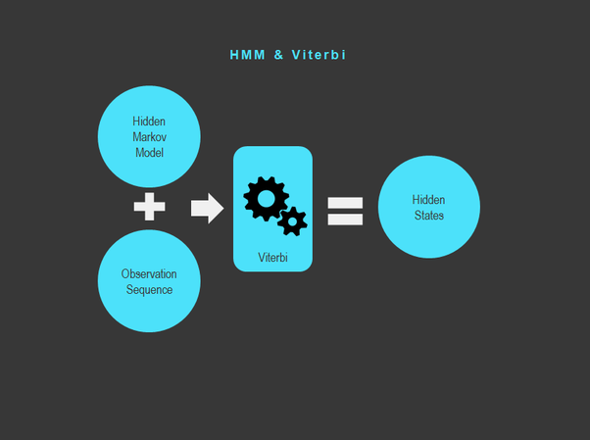

George now plans to draw information from the work roster to populate the model.

1. Start probabilities- What are chances of a starting in a state?

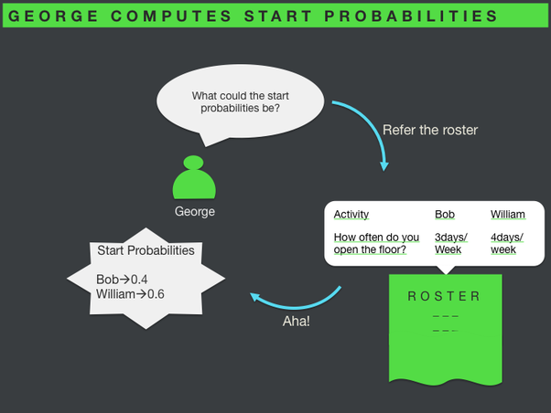

2. State Transition probabilities- How frequently do the states change?

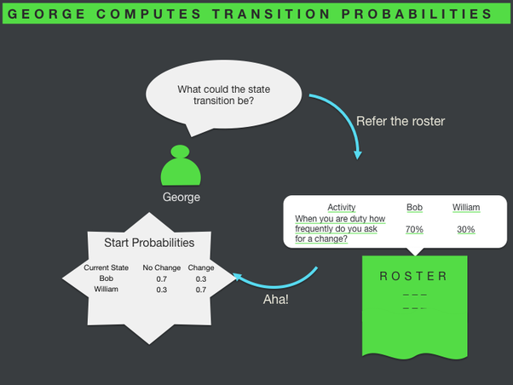

3. Emission probabilities- In any state, what are the chances of each observation?

George now has the crucial piece of information, the HMM, to get him close in on the culprit.